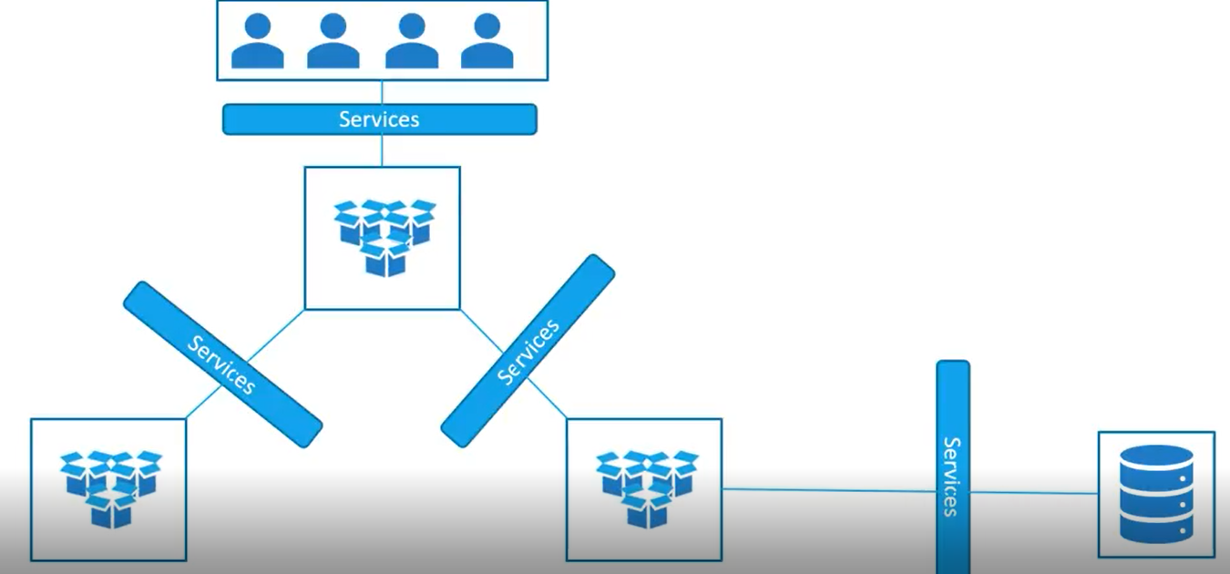

Services enables the application accessible to end users and also enables the connection between pods

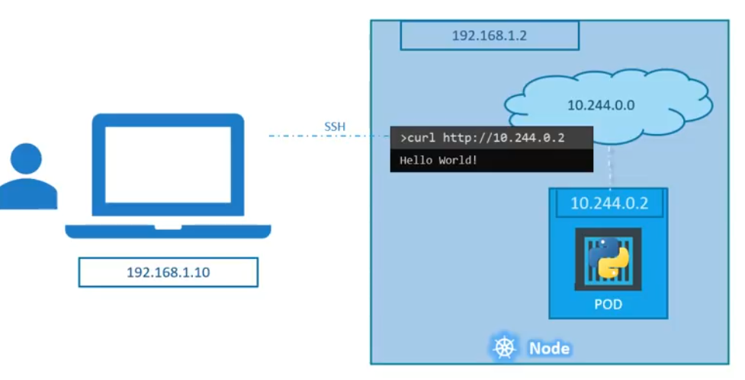

As above, if we want to curl the pod IP from inside the node, then its fine. But if we want to access from outside, we need services

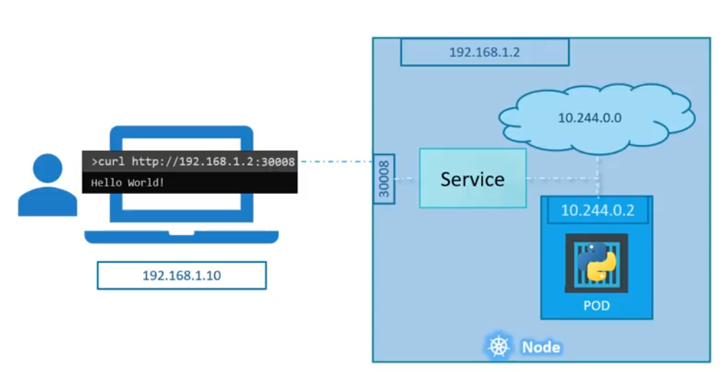

It listens the port on pod and forward to the node. This kind of service is called nodeport

Types of services:

Nodeport is used to expose the pod to exteenal world

Cluster IP creates an internal IP inside the cluster and enabled the communication between the pods. Like communication between front end pods to backend pods

Loadbalancer IP used to configure the LB ip of cloud platform to distribute the traffic to set of front end pods

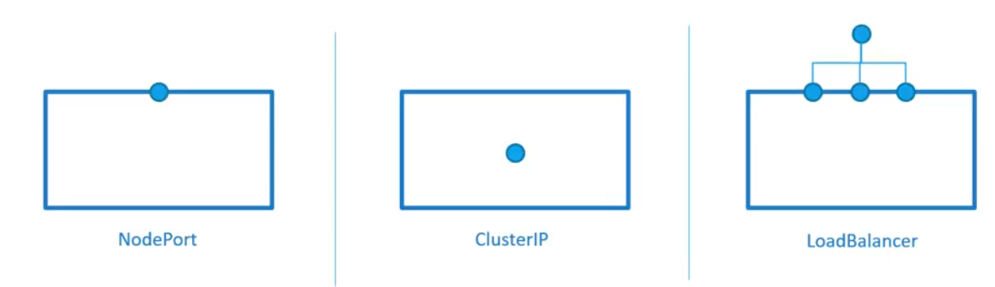

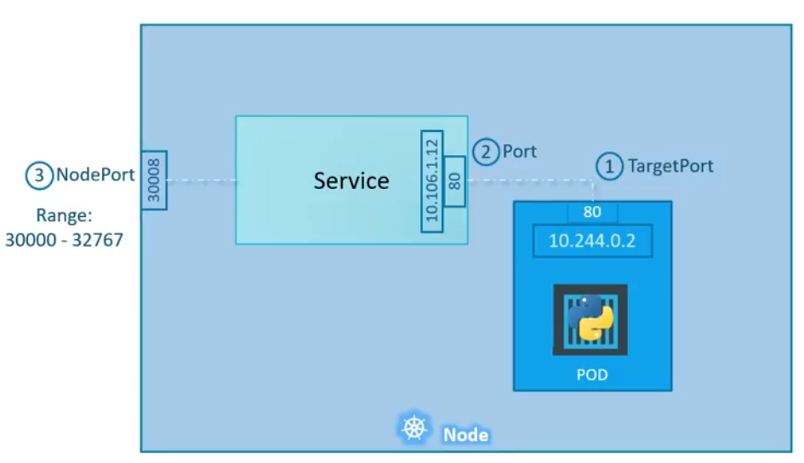

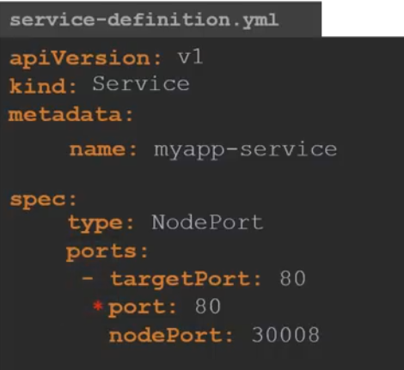

If we don’t specify the target port, then it will take port as a node port

And if we don’t specify nodeport then it will take any free port available in the valid range

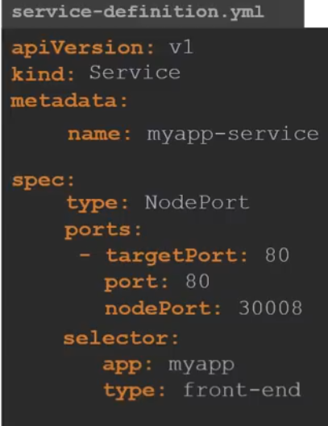

Now we need to use selector to connect the service with POD

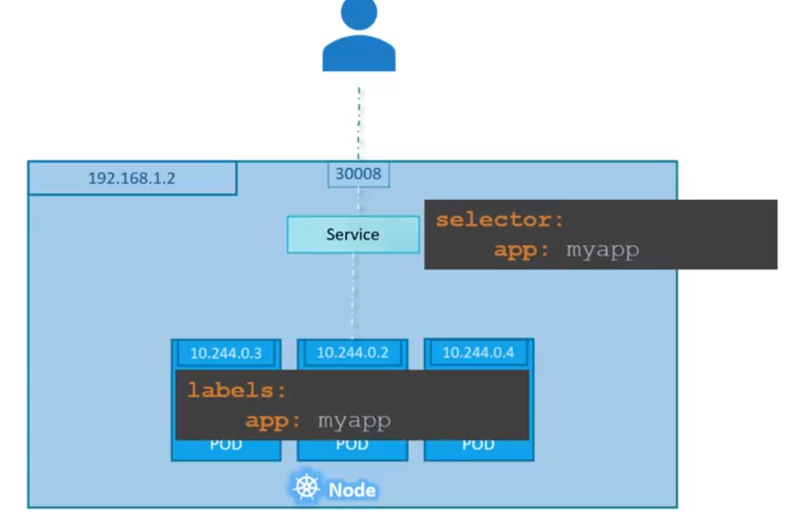

As above, we have 3 pods having the same label. So when we use the selector with that label details, services will find out those 3 pods and servers the request to all of them

It uses random algorithm to balance the load on 3 pods. It used internal load balancer to do that

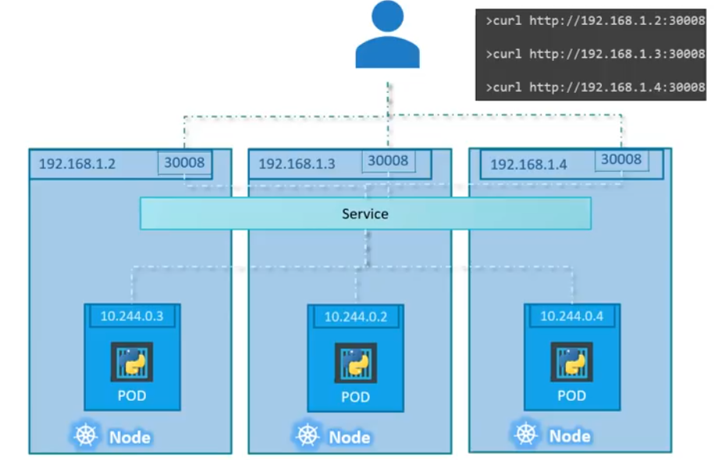

As above, if we have multiple pods on multiple servers, even though the service works in same way